|  |  |
| --- | --- |
| **Project Case** |  |
| COMP6144  Web Programming |
| **Computer Science** | **O202-COMP6144-AD02-00** |
| ***Valid on*** *Odd Semester Year 2020/2021* | **Revision 00** |

1. Seluruh kelompok tidak diperkenankan untuk:

*The whole group is not allowed to:*

* + - Melihat sebagian atau seluruh proyek kelompok lain,

*Seeing a part or the whole project from other groups*

* + - Menyadur sebagian maupun seluruh proyek dari buku,

*Adapted a part or the whole project from the figure*

* + - Mendownload sebagian maupun seluruh proyek dari internet,

*Downloading a part or the whole project from the internet,*

* + - Mengerjakan soal yang tidak sesuai dengan tema yang ada di soal proyek,

*Working with another theme which is not in accordance with the existing theme in the matter of the project,*

* + - Melakukan tindakan kecurangan lainnya,

*Committing other dishonest actions,*

* + - Secara sengaja maupun tidak sengaja melakukan segala tindakan kelalaian yang menyebabkan hasil karyanya berhasil dicontek oleh orang lain / kelompok lain.

*Accidentally or intentionally conduct any failure action that cause the results of the project was copied by someone else / other groups.*

1. Jika kelompok terbukti melakukan tindakan seperti yang dijelaskan butir 1 di atas, maka **nilai kelompok** yang melakukan kecurangan (menyontek maupun dicontek) akan di – **NOL** – kan.

*If the group is proved to the actions described in point 1 above, the score of the group which committed dishonest acts (cheating or being cheated) will be “Zero”*

1. Perhatikan jadwal pengumpulan proyek, segala jenis pengumpulan proyek di luar jadwal tidak dilayani.

*Pay attention to the submission schedule for the project, all kinds of submission outside the project schedule will not be accepted*

1. Jangan lupa untuk melihat kriteria penilaian proyek yang ditempel di papan pengumuman, atau tanya asisten anda.

*Don’t forget to look at the project assessment criteria that posted on the announcement board, or ask your teaching assistant.*

1. Persentase penilaiaan untuk matakuliah ini adalah sebagai berikut:

*Marking percentage for this subject is described as follows:*

|  |  |  |
| --- | --- | --- |
| **Tugas Mandiri**  *Assignment* | **Proyek**  *Project* | **UAP**  *Final Exam* |
| - | 100% | - |

1. Software yang digunakan pada matakuliah ini adalah sebagai berikut:

*Software will be used in this subject are described as follows:*

|  |
| --- |
| **Software**  *Software* |
| PHP Composer 1.10.7  PHP Storm 2020.1.2  Visual Studio Code  Laravel Framework 7  XAMPP 7.4.7  Firefox / Chrome |

## Ekstensi file yang harus disertakan dalam pengumpulan tugas mandiri dan proyek untuk matakuliah ini adalah sebagai berikut:

*File extensions should be included in assignment and project collection for this subject are described as follows:*

|  |  |
| --- | --- |
| **Tugas Mandiri**  *Assignment* | **Proyek**  *Project* |
| - | Folder Project (PHP, SQL, Image Files (JPG / PNG), ENV, HTML, CSS, SCSS, JS, JSON, HTACCESS, ARTISAN) |

## Soal

*Case*

General Provisions:

* Use **MySQL** asdatabase and must using **Laravel Migration** features.
* **All file upload** feature such as image and document must be **stored to server storage**.
* Use PHP Framework **Laravel 7** to build the project.
* Use Laravel **MVC** concept (**Model, View, Controller**) to build the project.
* Use **Eloquent Query / Query Builder** to work with database.
* You are free to design your own database table **based on given requirements**.
* Print screen given below is only an example. You are free to create your own user interfaces.
* It is **prohibited** to install any kind of Laravel packages. You must use fresh installation of **Laravel 7**.
* Only **validation** in the **backend** (using Laravel) will be graded.

**Mimi Figure Shop**

**Mimi Figure Shop** is a famous figure store in Indonesia. To expand its business, **Mimi Figure Shop** wants to create a website for their store. In that website, user can find information about the **figure** and order it. This website enables the customers to know what the inside of **Mimi Figure Shop** is.

As a web developer, you are asked to create a website using **Laravel** **7** for this online figure store. There are three types of user’s role in this website: **Admin**, **Member**, and **Guest** (**non-logged-in user**).

Each page shows **greeting to user**, and **current** **date** **time**. The descriptions for each page are:

1. Login Page

This page is accessible only to **guest**. This page allows user to log in to the website. Display an **error message** on the login page if user enters wrong combination of **Email** and **Password**.

If user has entered correct **Email** and **Password**, redirect user to the **Home Page** based on the user’s role. If user checks the “**Remember Me**” checkbox, the website will save the **Email** and **Password** using cookies.

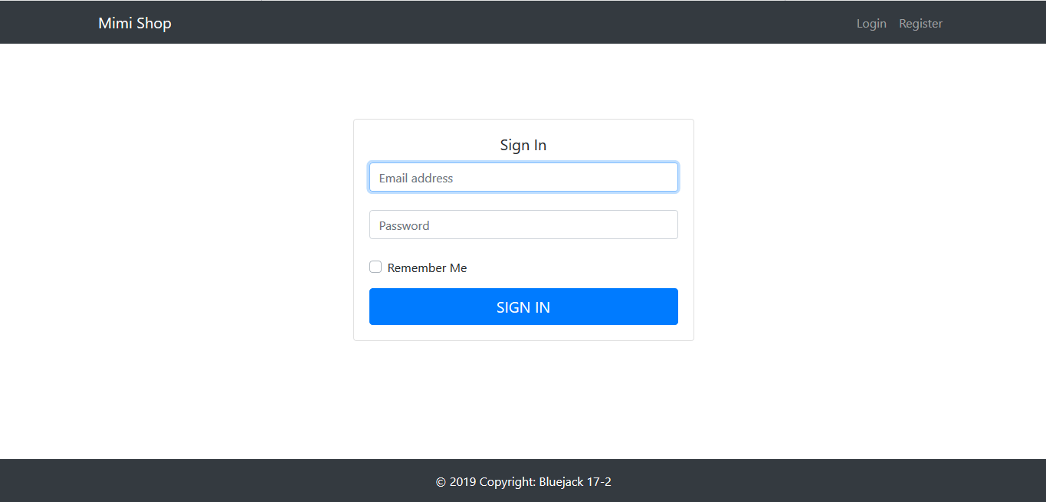

***Figure 1. Login Page***

1. Register Page

This page is accessible only to **guest**. This page allows guests to **register** themselves as **Mimi Figure Shop** member. Display an **error message** if user input incorrect personal data.

The following table shows the existing fields on this page and the validation for each field.

|  |  |
| --- | --- |
| **Field** | **Information** |
| **Full Name** | Must be filled with **at least 5 characters** |
| **Email** | Must be filled with **email** and **unique** |
| **Password** | Must be filled with **alphanumeric** and **at least 5 characters** |
| **Confirm Password** | Must be filled and **same with password** |
| **Phone** | Must be filled with **numeric** and **at least 11 characters** |
| **Gender** | Must be selected between **male** or **female** |
| **Address** | Must be filled with **at least 10 characters** |
| **Profile Picture** | Must be selected and must match one of the **allowed MIME types** (**jpeg**, **png**, **jpg**) |
| **Terms and Condition** | Must be checked |

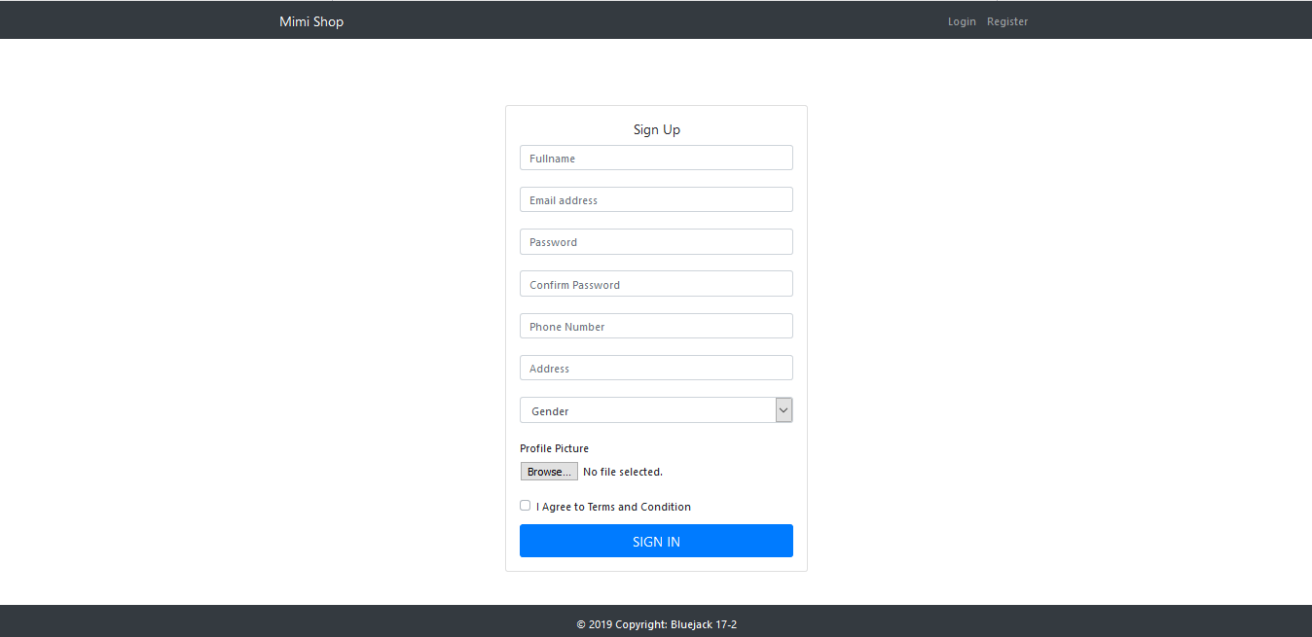

***Figure 2. Register Page***

1. Home Page

This page is accessible to **all users**. This page allows user to see all **figures information** and **search figure by** **either** **name or category**. Figures information is displayed using **pagination** with **6 figures for each page**.

In this page, there is an **Add to Cart** button. Validate the buttons to be **visible** for **member** (**invisible** for both **guest** and **admin**), also validate the figure quantity must be **greater than 0**. If **user** click **Add to Cart** button, **insert** selected figure **to member**’**s cart**. If the figure has already **existed** in **member**’**s** **cart**, then **increase cart**’**s figure** **quantity** by **one**.

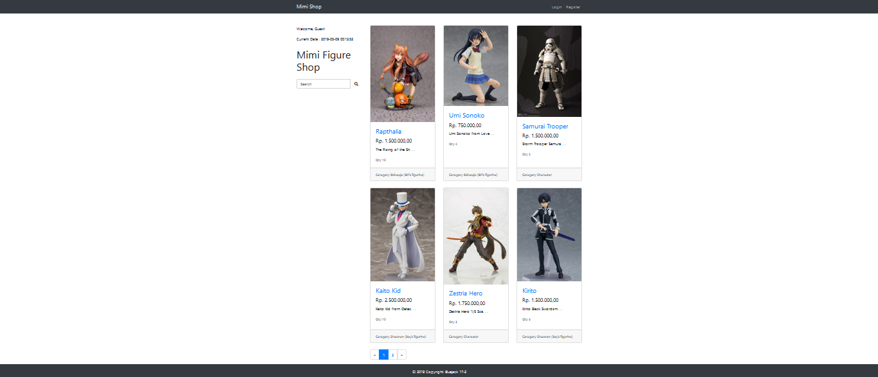

***Figure 3. Home Page (for Guest)***

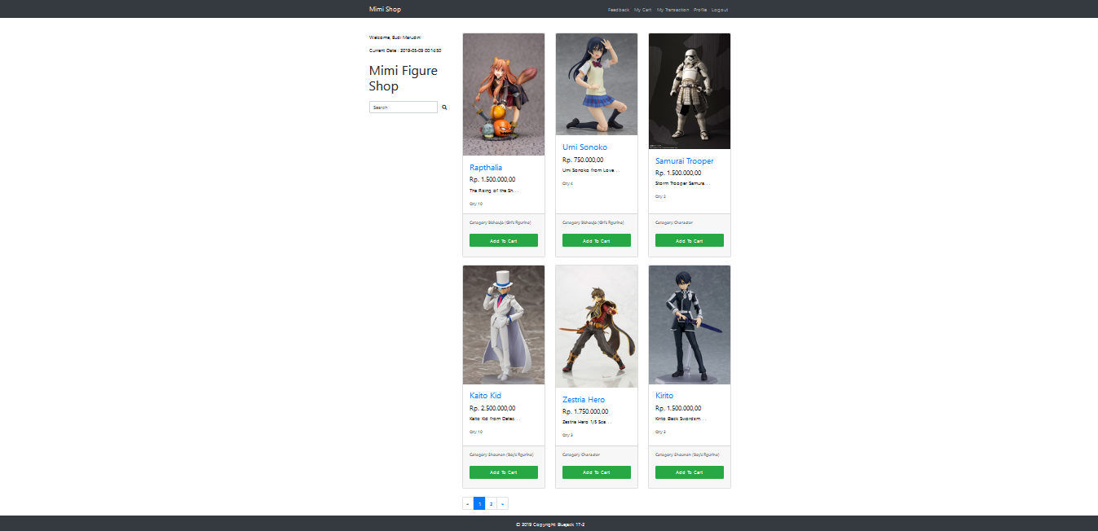

***Figure 4. Home Page (for Member)***

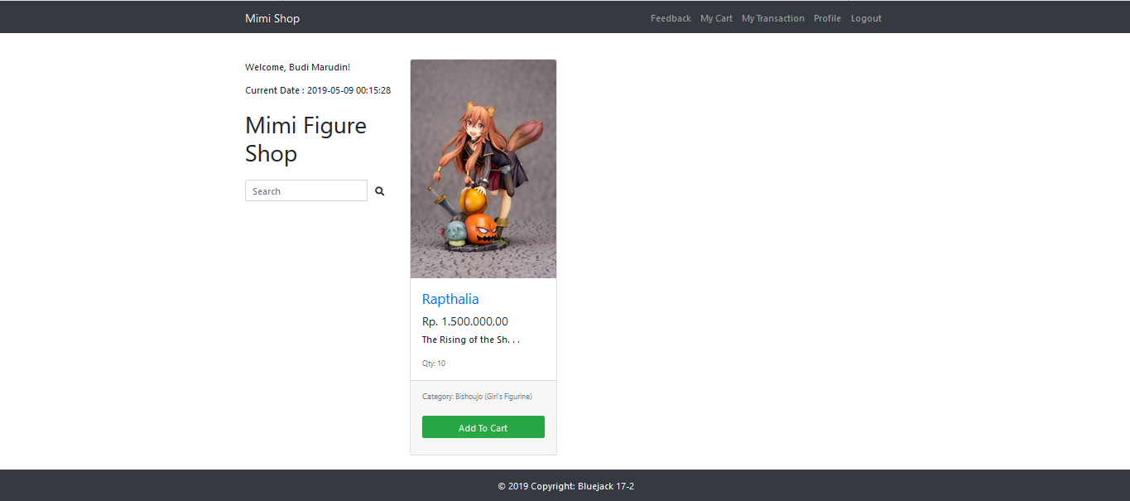

***Figure 5. Searching Figure with ‘Rapthalia’ keyword***

1. Figure Details Page

This page is accessible to **all users**. If user clicks the **Figure**’**s name** in **homepage**, Redirect user to this details page. This page displays all **figure details** such as **figure’s name**, **figure’s description**, **figure’s category**, **figure’s price**,and **figure’s current stock** (**quantity**).

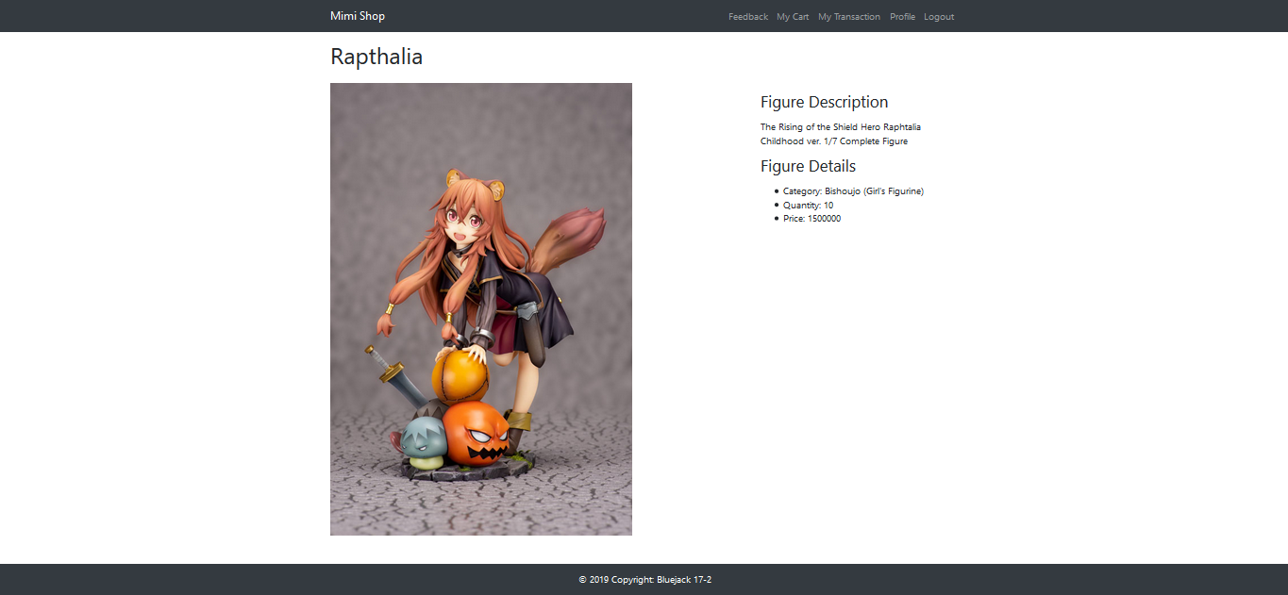

***Figure 6. Figure Details***

1. Cart Page

This page is accessible to **all users**. This page displays all figures that have been added into user’s shopping cart. Display cart information such as **figure’s picture**, **figure’s name**, **figure’s quantity**, **figure’s** **price**,and **total figure’s price**.

There are Two types of button in this page, **Remove** button for each figure on cart and **Checkout** button. If **users** click **Remove** button, then **remove selected figure** from the **cart**, and if **users** click **Checkout** button, then **all shopping cart** **data** will be **deleted** and **insert** current transaction data into user’s **transaction history**.

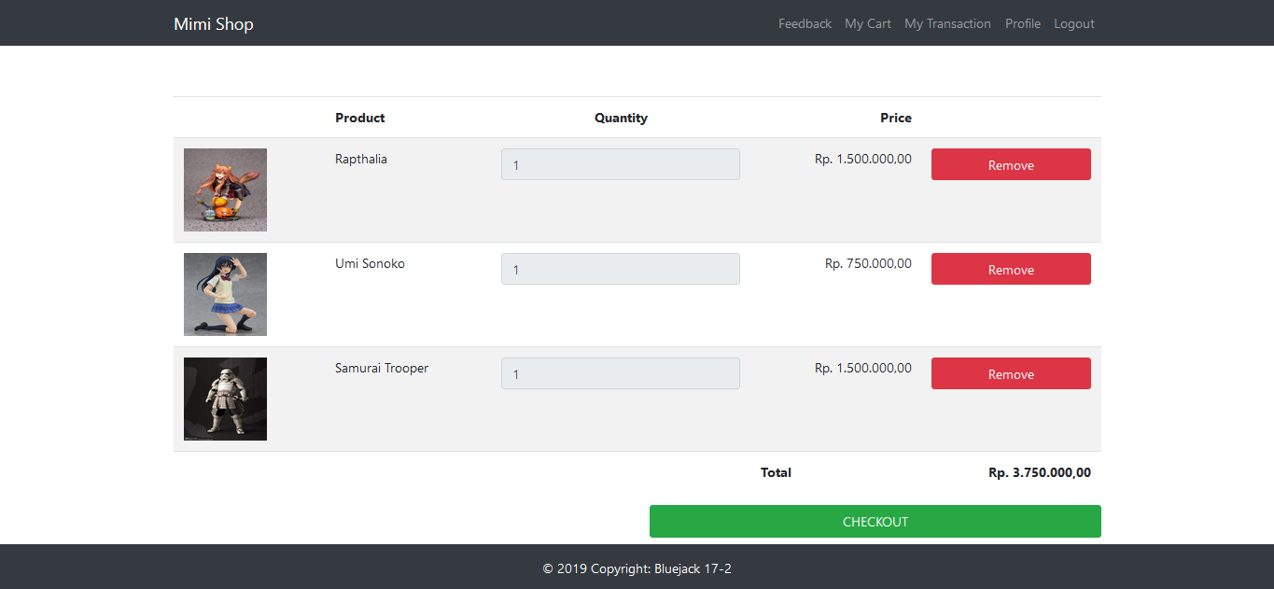

***Figure 7. Cart Page***

1. Manage Figure

This page is accessible only to **admin**. This page allows **admin** to **insert**, **update**, and **delete** the figure. Figure list is displayed using **pagination** with **6 figures for each page**.

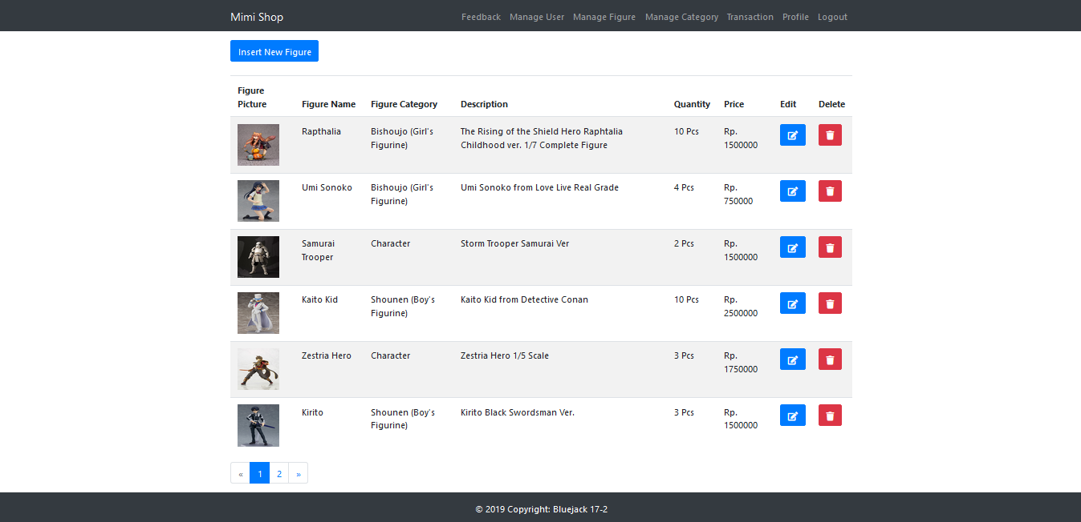

***Figure 8. Manage Figure Page***

If **admin** click **Insert New Figure** button, redirect **admin** to **Insert Figure page**. **Admin** can fill the **Insert Figure Form** and click **Insert** button to insert new figure data into database. Display **error message** if **admin** input incorrect figure data on **Insert Figure Form**.

The following table shows existing fields in the **Insert Figure Form** and the validation for each field:

|  |  |
| --- | --- |
| **Field** | **Information** |
| **Name** | Must be **filled** with **at least 5 characters** |
| **Category** | Must be **selected** |
| **Price** | Must be **filled**, **numeric**, and **must be more than 100000** |
| **Description** | Must be filled with **at least 10 characters** |
| **Stock** | Must be filled, **numeric**,and **more than 0** |
| **Image** | Must be selected and must match one of the **allowed MIME types (jpeg**, **png**, **jpg)** |

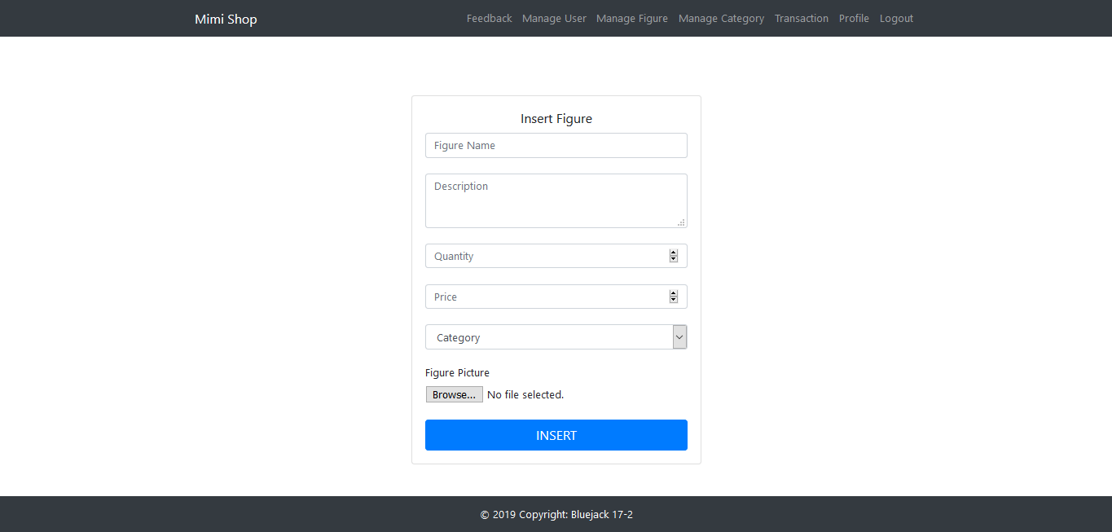

***Figure 9. Insert New Figure Page***

Each figure in the lists have ‘**Edit**’ and ‘**Delete**’ buttons:

* If **admin** click **Edit** button, redirect admin to **Edit Figure** page
* If **admin** click **Delete** button, **delete** selected figure

1. Update Figure Page

This page is accessible only to **admin**. This page allows **admin** to update existing figure. This page will be shown if **admin** clicks **Edit Figure** button in **Manage** **Figure** page. Display **error message** if **admin** input incorrect figure data.

The following table shows existing fields in the page and the validation for each field:

|  |  |
| --- | --- |
| **Field** | **Information** |
| **Name** | Must be **filled** with **at least 5 characters** |
| **Category** | Must be **selected** |
| **Price** | Must be **filled**, **numeric**, and **must be more than 100000** |
| **Description** | Must be filled with **at least 10 characters** |
| **Stock** | Must be filled, **numeric,** and **more than 0** |
| **Image** | Must be selected and must match one of the **allowed MIME types (jpeg**, **png**, **jpg)** |

If admin click **Update** button, then **update** current selected figure with updated data. After that, redirect admin back to **Manage Figure** page.

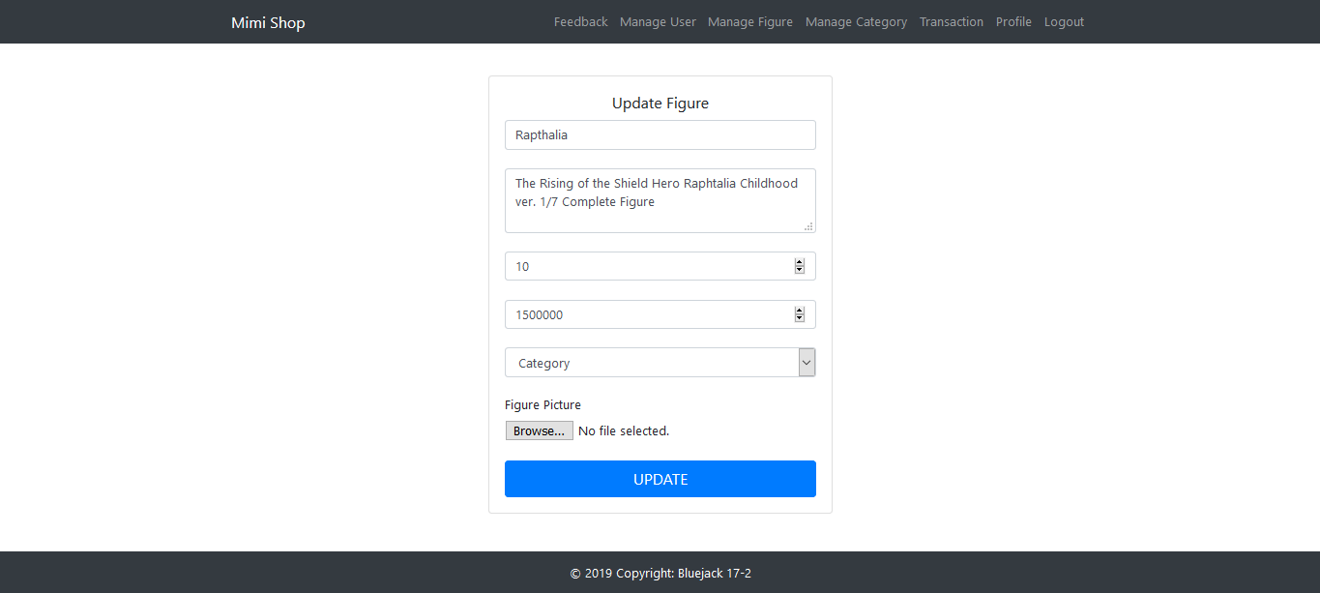

***Figure 10. Update Figure Page***

1. Manage Figure Category

This page is accessible only to **admin**. This page allows **admin** to **insert**, **update**, and **delete** figure category.

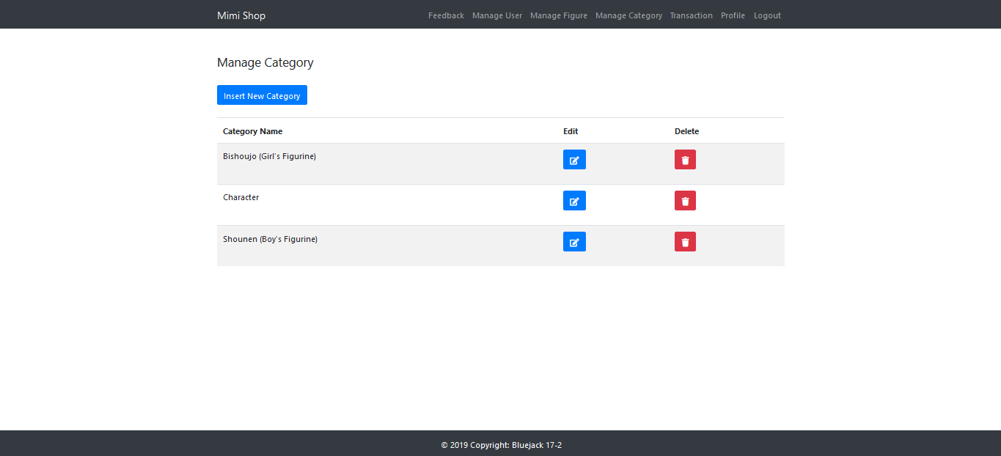

***Figure 11. Manage Figure Category Page***

If **admin** click **Insert New Category** button, redirect user to **Insert Category** page. A**dmin** can fill the **Insert Category Form** and click **Insert** button to insert new category data into database. Display **error message** if **admin** input incorrect category data on **Insert Category Form**.

The following table shows existing fields in the **Insert Category Form** and the validation for each field:

|  |  |
| --- | --- |
| **Field** | **Information** |
| **Category Name** | Must be **filled** with at least **5 characters** |

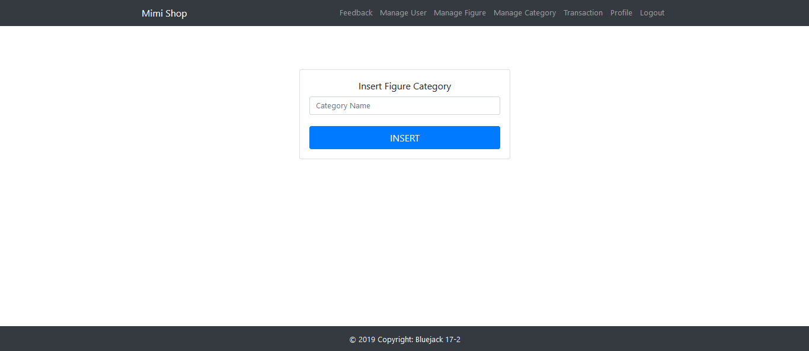

***Figure 12. Insert Figure Category***

Each category in the lists have ‘**Edit**’and ‘**Delete**’buttons:

* If **admin** click **Edit** button, redirect admin to **Update Category** page
* If **admin** click **Delete** button, **delete** selected category

1. Update Category Page

This page is accessible only to **admin**. This page allows **admin** to update existing figure’s category. This page will be shown if **admin** clicks **Edit Category** button in **Manage** **Category** page. Display **error message** if **admin** input incorrect category data.

The following table shows existing fields in the page and the validation for each field:

|  |  |
| --- | --- |
| **Field** | **Information** |
| **Category Name** | Must be **filled** with **at least 5 characters** |

If admin click **Update** button, then update current selected category with updated data. After that, redirect admin back to **Manage Category** page.

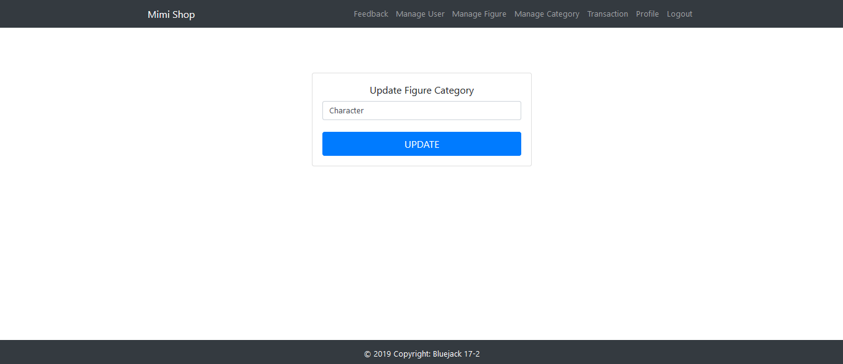

***Figure 13. Update Category Page***

1. Manage Feedbacks Page

This page is accessible only to **admin**. This page allows **admin** to **update** feedbacks status.

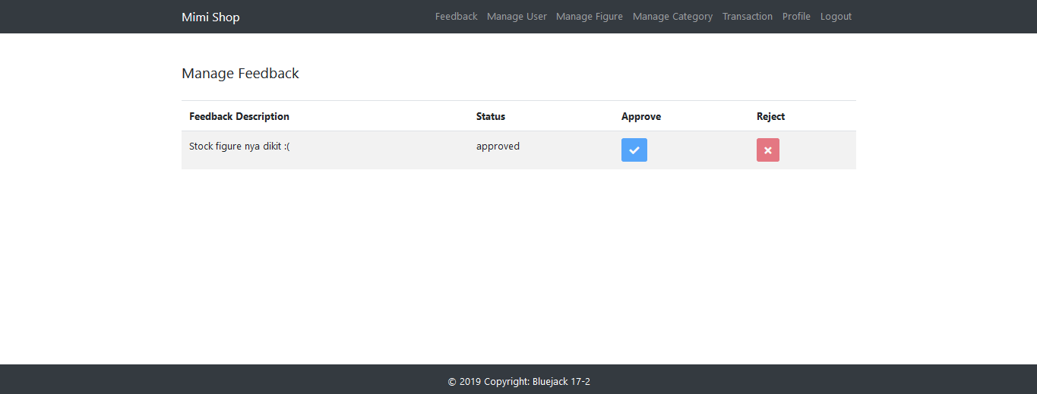

***Figure 14. Manage Feedbacks Page***

If admin click **Approve** button, then update current selected feedback status to ‘**approved**’ or if admin click **Reject** button, then update current selected feedback status to ‘**rejected**’. After that, redirect admin back to **Manage Feedback** page.

1. Profile Page

This page is accessible only to **admin** and **member**. This page allows **admin** and **member** to **view** and **update** their personal data. Display **error message** if **admin** or **member** input incorrect personal data.

The following table shows existing fields in this page and the validation for each field:

|  |  |
| --- | --- |
| **Field** | **Information** |
| **Full Name** | Must be filled with **at least 5 characters** |
| **Email** | Must be filled with **email** and **unique** |
| **Phone** | Must be filled with **numeric** and **at least 11 characters** |
| **Address** | Must be filled with **at least 10 characters length** |
| **Gender** | Must be selected between **male** or **female** |
| **Profile Picture** | Must be selected and must match one of the **allowed MIME types (jpeg**, **png**, **jpg)** |

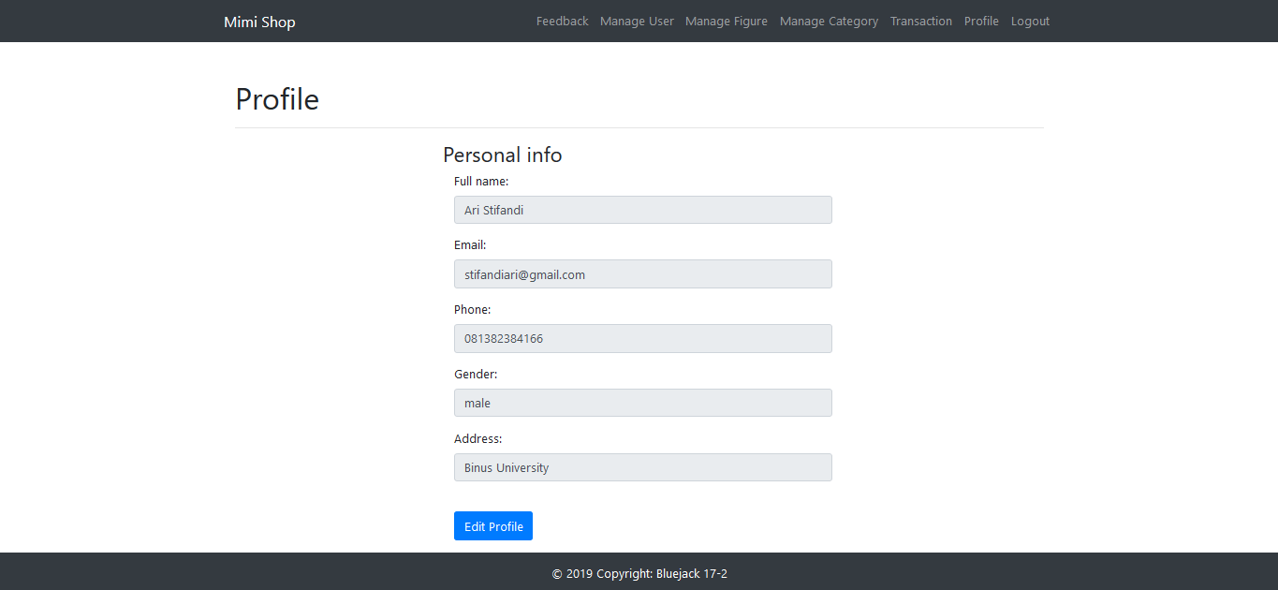

***Figure 15. Profile Page***

1. Manage Users

This page is accessible only to **admin**. This page allows **admin** to **update** and **delete** users registered in **Mimi Figure Shop**.

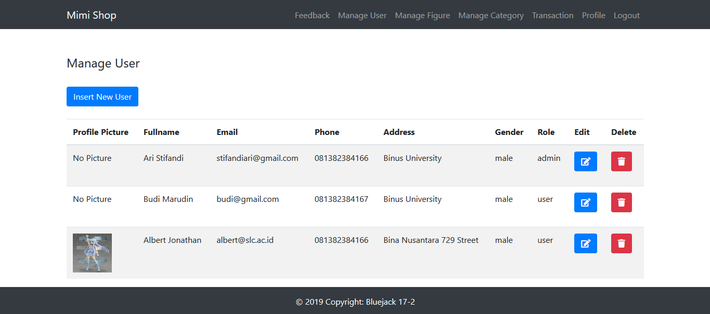

***Figure 16. Manage Users Page***

Each user in the lists have ‘**Edit**’and ‘**Delete**’buttons:

* If **admin** click **Edit** button, redirect user to **Edit User** page
* If **admin** click **Delete** button, **delete** selected user

1. Update Users Page

This page is accessible only to **admin**. This page allows **admin** to update existing user. This section will be shown if **admin** clicks **Edit** button in **Manage** **Users** page. Display **error message** if **admin** input incorrect user’s data.

The following table shows existing fields in the page and the validation for each field:

|  |  |
| --- | --- |
| **Field** | **Information** |
| **Full Name** | Must be filled with **at least 5 characters** |
| **Email** | Must be filled with **email** and **unique** |
| **Phone** | Must be filled with **numeric** and **at least 11 characters** |
| **Address** | Must be filled with **at least 10 characters length** |
| **Gender** | Must be selected between **male** or **female** |
| **Role** | Must be selected between **member** or **admin** |
| **Profile Picture** | Must be selected and must match one of the **allowed MIME types (jpeg**, **png**, **jpg)** |

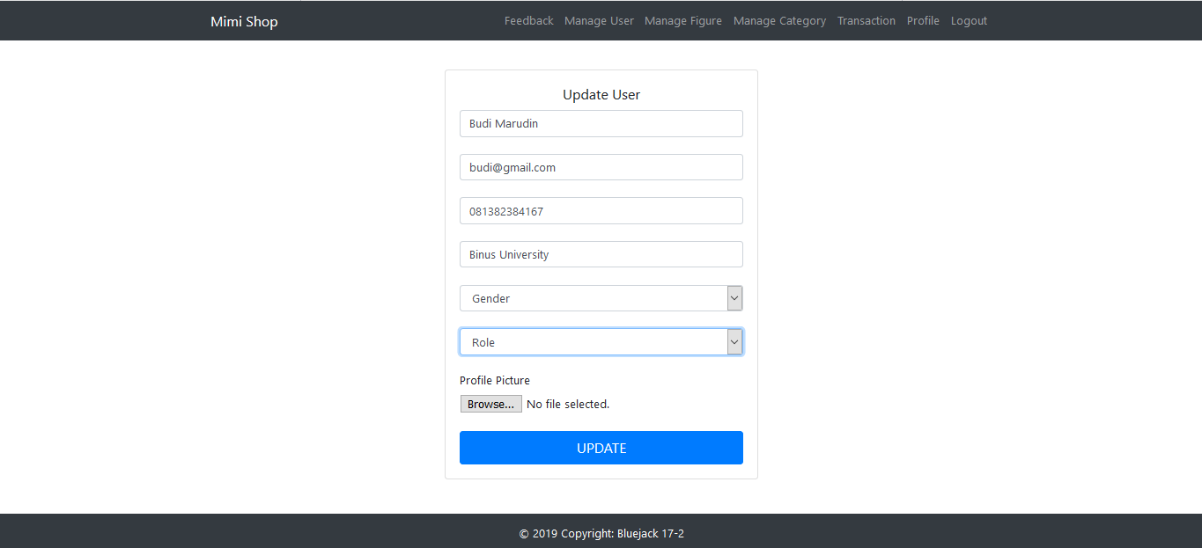

***Figure 17. Update User Page***

1. Transaction History

This page is accessible only to **admin** and **member** to show all transaction history. Show **all member’s transaction history** for **admin**, while for **member**, show **only their transaction history**. The information of transaction that must be shown are **transaction number**, **transaction date**, **buyer’s name**, **figure’s picture**, **figure’s name**, **figure’s quantity**, **figure’s price**, and **total price**. Transaction History information is displayed using **pagination** with **1 transaction for each page**.

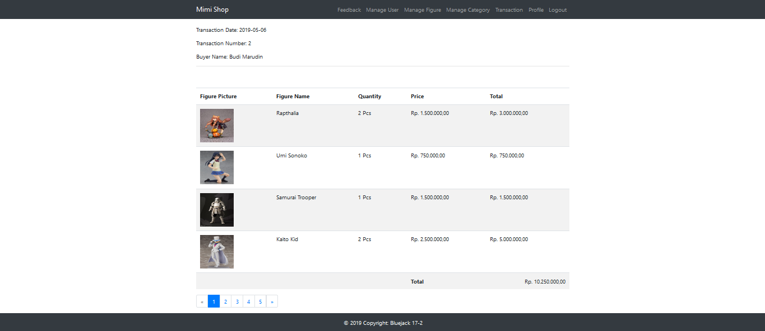

***Figure 18. Transaction History Page***

1. Insert Feedback

This page is accessible only to **member** to insert new feedback. Display **error message** if **member** input incorrect feedback’s data.

The following table shows existing fields in the page and the validation for each field:

|  |  |
| --- | --- |
| **Field** | **Information** |
| **Feedback** | Must be filled with **at least 10 characters** |

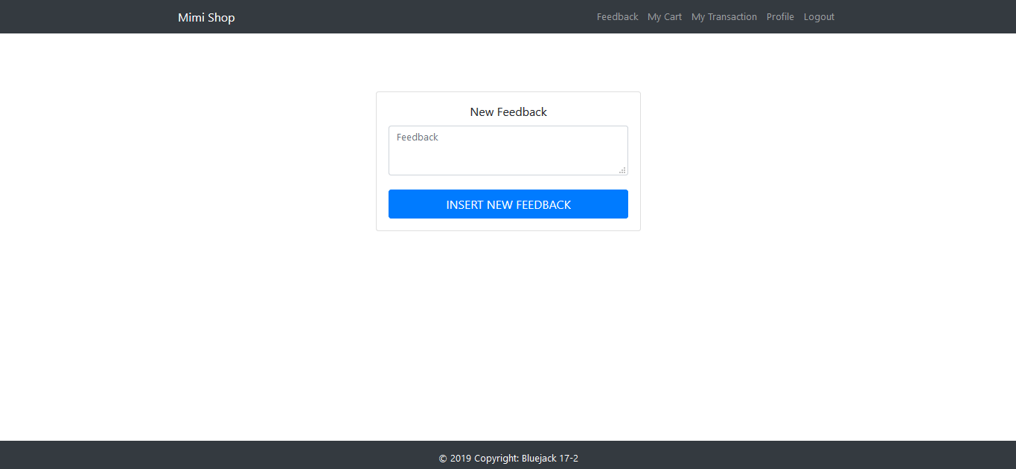

***Figure 19. Insert Feedback Page***

Here are the rules that you must follow to create your project:

1. Use appropriate software for this subject based on **Sistem Praktikum** that can be downloaded from Binusmaya.
2. Collect appropriate files for this subject based on **Sistem Praktikum** that can be downloaded from Binusmaya.
3. Include the other files that can support your project, such as:
   * All files in your project
   * Other files (image, audio, video, etc.) used in your project
   * *.DOC file (documentation of your project) that contains all pages in your project, reference links of additional files (image, audio, video, etc.) used in your project, the description about how to use your application, etc
4. If there are some hidden creativities, please note them in the existing documentation because they can greatly affect your project score